Select Second Signature.docx Mar 15, 2015 Chip Nevins

A new drop-down ‘select second signature’ is now on the final reports and patient reports. You can use this to select the person who will appear in the second signature line.

Final Report

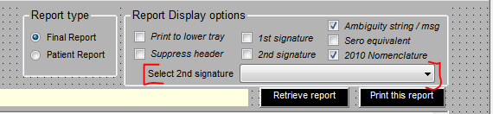

The report always prints Neng Yu’s signature, and if you click the checkbox for second signature, it prints the person you selected.

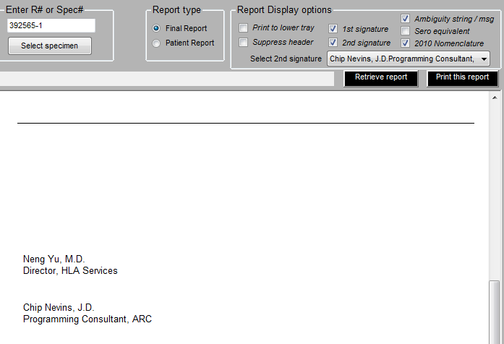

If you want to add people who appear on this select list, you need to use the administrative function in canned comments.

Menu path: Admin > Data Entry > Canned Comments

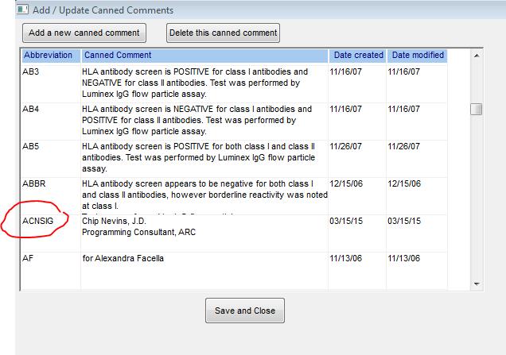

You add a new canned comment. The abbreviation for the comment must end with the letters ‘SIG’. All canned comments ending in these letters are considered to be ‘signatures’, and they will be included in the new drop-down.

On final reports, when you select a new entry from the drop down, you are prompted to re-retrieve the report data.

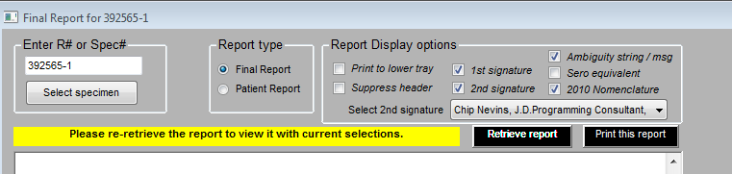

On the patient reports the signatures are adjusted automatically when you change them.